# Wi-Fi Connectivity

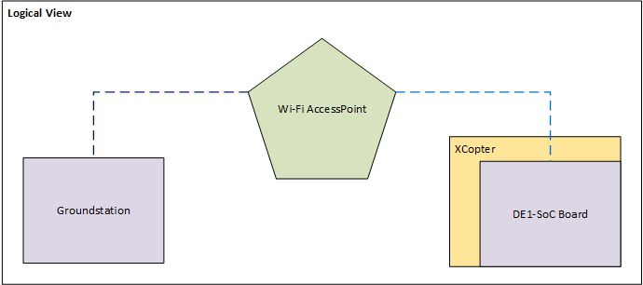

Figure 1: The logical view of the Wi-Fi components

The X-Copter needs a wireless connection to transmit/receive data to/from ground station. The data consists of position, status, speed and further information about the current air situation. The basic configuration is a PC/Laptop and a Wi-Fi dongle (from Edimax with an RTl8188 chip) plugged in the X-Copter DE1-SoC board (DE1). Both are connected with an access point (AP) (Figure 1: The logical view of the Wi-Fi components).

## Implementing the Driver

First step to solve this challenge was to establish a connection between the DE1 and the AP. The Wi-Fi dongle doesn’t work out of the box. To get the dongle working there were two possibilities. First one was to compile a Linux driver and the second was to edit the operating system.

The driver can be downloaded from the manufacturer’s website. It was necessary to cross-compile the driver on the host x86 system for the target platform with an ARMv7 architecture. It’s a big underpinning to understand the makefile(s) and it is often not clear how to fix an error. After failing the task this way it was decided to edit the operating embedded system and include the drivers in Buildroot.

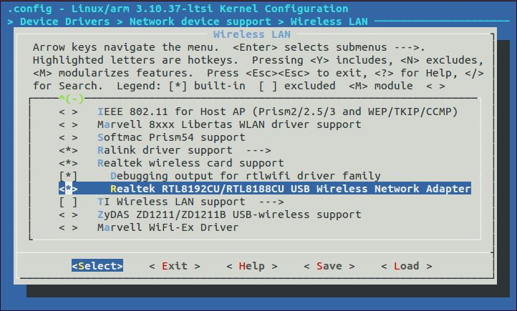

Figure 2: Buildroot driver selection

Buildroot was used to generate the embedded Linux, the bootloader and the root filesystem. At first the right device driver cannot be found in the basic settings. After activating some other components, additional devices were added to the Wi-Fi driver list (Figure 2: Buildroot driver selection). Now the driver file can be loaded successful but there was an error with a missing firmware file. Adding the right firmware in Buildroot solved this issue. Now the basic settings are set and the DE1 can establish a wireless connection to the AP.

## Configure the Wi-Fi connection

To configure the network there are two files to edit. One is the */etc/network/interfaces* and the other is the */etc/wpa_supplicant*. In the interfaces file has to be set up following changes (Figure 2: Interface configuration file):

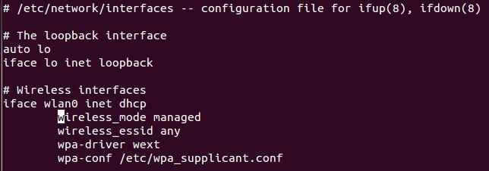

Figure 3: Interface configuration file

The wpa_supplicant (Figure 3: wpa_supplicant file) file needs the next showing entries to work.

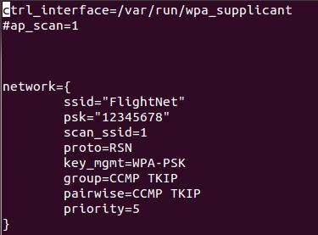

Figure 4: wpa_supplicant file

To get an IP lease from AP it is necessary that the daemon *wpa_supplicant* is running. To start the background process, type the command

*/usr/sbin/wpa_supplicant –I wlan0 –D nl80211 –c /etc/wpa_supplicant.conf*

into the terminal. It is recommend to let this automatically do at the start up. Making a new file in the */etc/init.d/* folder with the file name *S50start_wlan* and insert the content of Figure 4: Content of the start-up script.

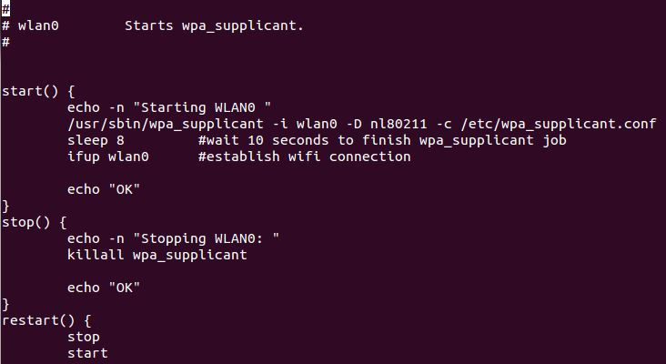

Figure 5: Content of the start-up script

## Result

The hardware driver is included and the Wi-Fi connection is established. At booting Linux, the wpa_supplicant daemon is starting and the IP leases automatically. The connection is encrypted and is secured for non-authorization access. The Wi-Fi connection was successful tested with MAVLink protocol. The ground station QGroundControl was running on a notebook and on our portable system-on-a-chip device the cross compiled heartbeat test application was sending a continuous proof of life over the air.